AI Assisted coding Assignment-20.5
Name:E.Srivarsha
Batch-44
HTNO:2303a52343
Task 1 – Password Storage Vulnerability Check
Prompt: Generate a Python user registration program that stores username and password.
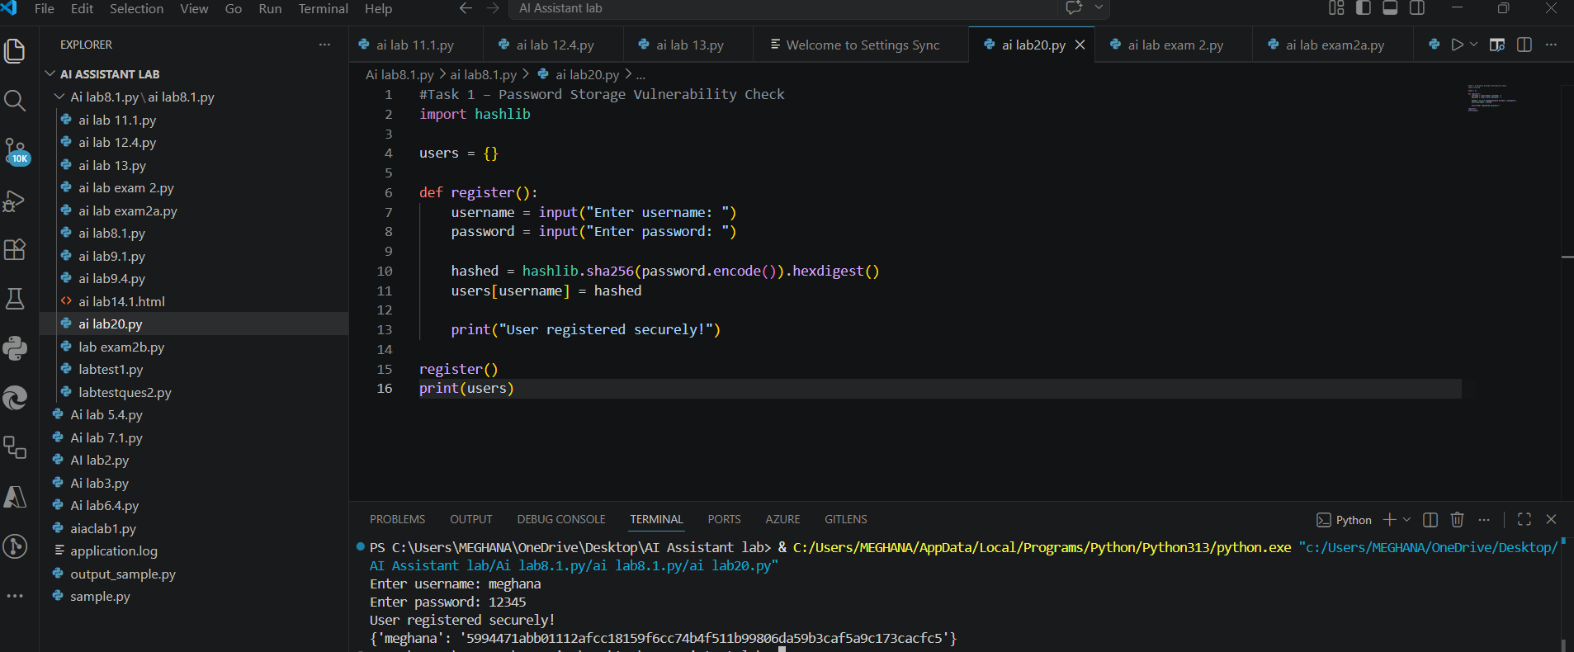
Observation:
1.The AI-generated code stores user passwords in plain text format without any encryption or hashing.
2.This means anyone with access to the database or program memory can easily read all user passwords.
3.Plain text password storage makes the system highly vulnerable to data breaches and unauthorized access.
4.If the system is compromised, attackers can directly use the exposed passwords to log in or perform malicious activities.
5.The code does not follow secure coding practices such as password hashing or salting.
Task 2 – Hardcoded Secrets Detection
Prompt:Generate a Python script that connects to an external API using an API key.
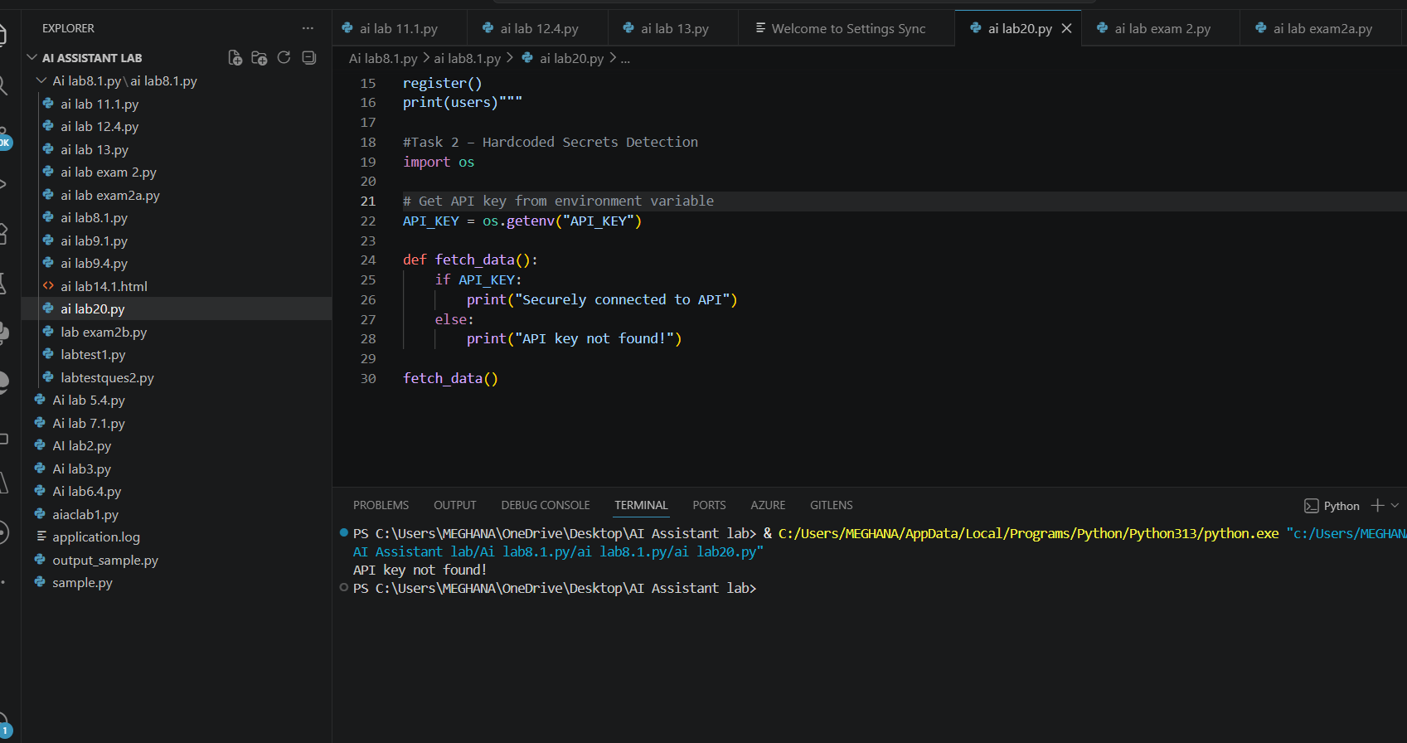
Observation
1.The API key is hardcoded directly in the source code.
2.This exposes sensitive information if the code is shared or uploaded to public repositories (e.g., GitHub).
3.Attackers can easily steal the API key and misuse the service.
4.It violates secure coding practices for secret management.
Task 3 – File Upload Security Validation
Prompt:Generate a Flask file upload program that allows users to upload files.
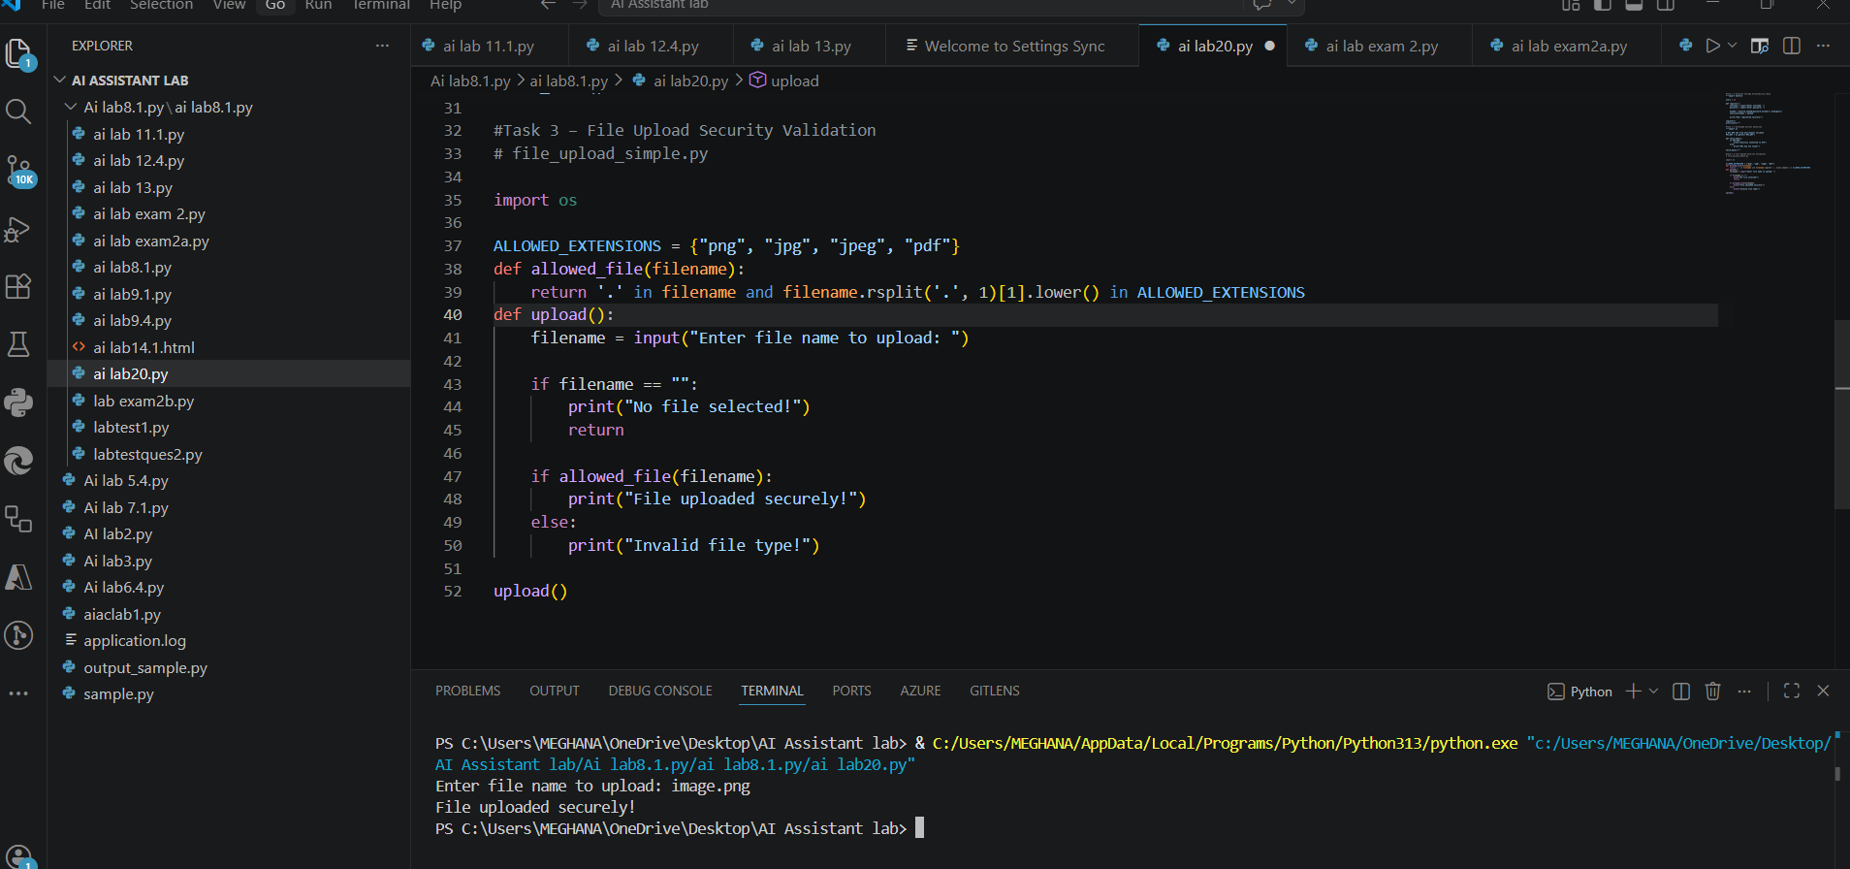
Observation:
1.The AI-generated file upload code initially allowed all types of files without any restriction.
2.This creates a major security risk, as attackers can upload malicious or executable files such as .exe, .py, or scripts.
3. There was no file size limit, which can lead to server overload or denial-of-service attacks.
4. The filename was not sanitized, making the system vulnerable to directory traversal attacks or file overwriting.
Task 4 – Command Injection Prevention
Prompt:Generate a Python script that executes system commands using user input
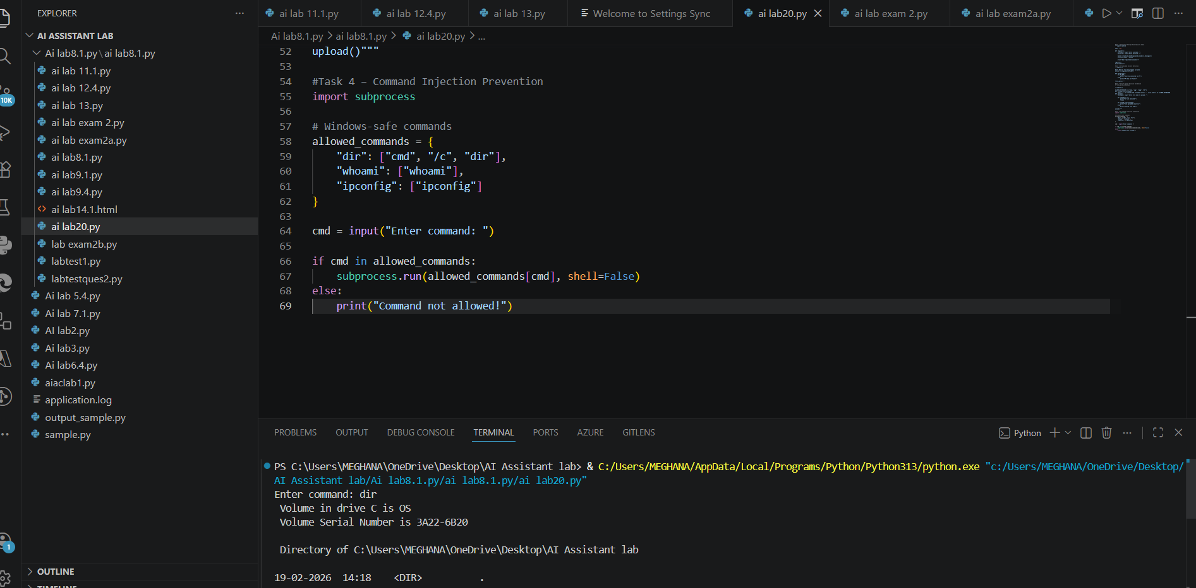
Observation:
1.The AI-generated code uses os.system() to execute commands directly from user input, which is highly insecure.
2.This allows attackers to inject and execute malicious system commands (command injection attack).
3.There is no input validation or restriction, making the system vulnerable to unauthorized operations.
4. Additionally, some commands may fail on certain operating systems (e.g., Windows) if they are not valid executables.
Task 5 – Secure Input Handling in Web Forms
Prompt:Generate an HTML + Flask feedback form.
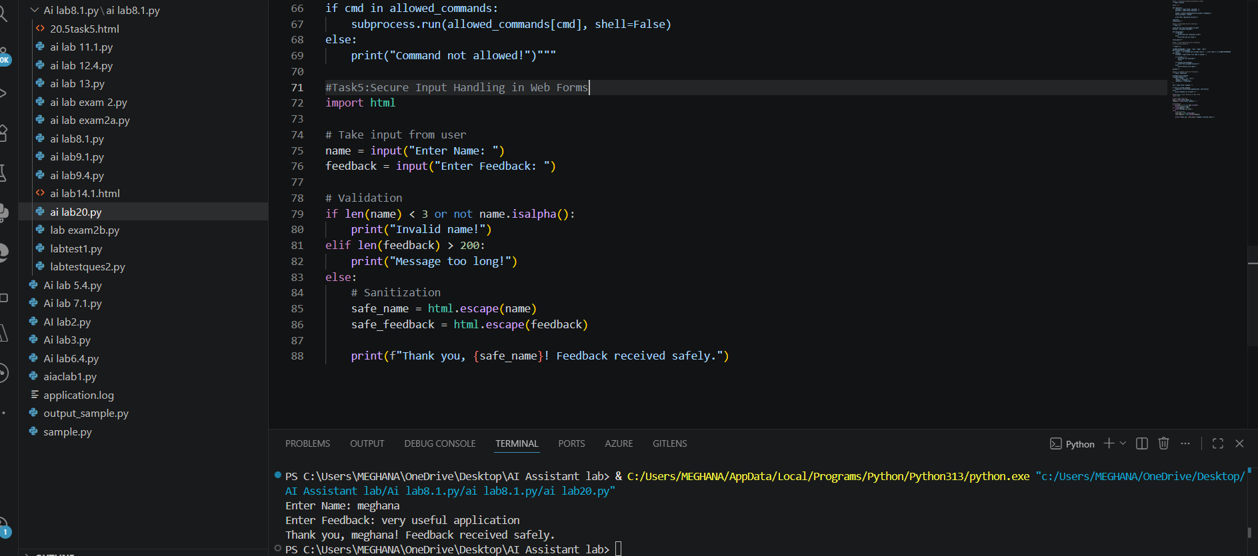

Observation
1.User input is directly displayed without validation
2.Vulnerable to XSS (Cross-Site Scripting) attacks
3.No input sanitization or filtering

